LAB No. 7
Implementation of Recurrent Neural Network (RNN)
In this lab, students will study and implement a Recurrent Neural Network (RNN), a deep learning model designed for sequential and time-dependent data. Unlike feedforward neural networks, RNNs have feedback connections that allow them to retain information from previous time steps. Students will begin with a simple RNN model to understand sequence processing and then apply RNNs to real-world problems such as sequence classification and text processing. Model performance will be evaluated using accuracy metrics.
Introduction
A Recurrent Neural Network (RNN) is a class of neural networks specifically designed to process sequential data, where the order of inputs matters. RNNs maintain a hidden state (memory) that captures information from previous inputs and influences current predictions.
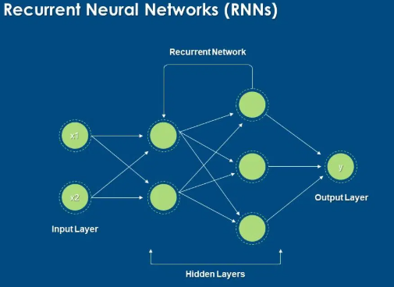

Key Concepts:
- Sequential Input – time series or text data
- Hidden State – stores past information
- Recurrent Connection – connects previous output to current input
- Activation Functions – tanh, ReLU
- Backpropagation Through Time (BPTT) – training method for RNNs
RNNs are commonly used in speech recognition, sentiment analysis, time-series forecasting, and natural language processing. However, basic RNNs may suffer from the vanishing gradient problem, which is addressed by advanced variants like LSTM and GRU.
Solved Examples:
Example 1:
Simple RNN for Binary Sequence Classification
Build a simple RNN to classify whether a sequence indicates Pass (1) or Fail (0) based on study performance over time.
Solution:
import numpy as np
from tensorflow.keras.models import Sequential
from tensorflow.keras.layers import SimpleRNN, Dense

# Sample sequential data (5 students, 3 time steps, 1 feature)
X = np.array([
[[1], [1], [0]],
[[1], [1], [1]],
[[0], [0], [1]],
[[0], [0], [0]],
[[1], [0], [1]]
])

y = np.array([1, 1, 0, 0, 1])

# Build RNN model
model = Sequential()
model.add(SimpleRNN(8, activation='tanh', input_shape=(3, 1)))
model.add(Dense(1, activation='sigmoid'))

# Compile and train
model.compile(optimizer='adam', loss='binary_crossentropy', metrics=['accuracy'])
model.fit(X, y, epochs=100, verbose=0)

# Prediction
prediction = model.predict([[[1], [1], [1]]])
print("Predicted Result (1=Pass, 0=Fail):", int(prediction[0][0] > 0.5))

Explanation
The RNN processes input sequences and uses memory to capture temporal patterns before making a classification.
Example 2:
RNN for Time Series Prediction Predict the next value in a simple numerical sequence using an RNN.
Solution:
# Generate sequence data
X = np.array([
[[1], [2], [3]],
[[2], [3], [4]],
[[3], [4], [5]],
[[4], [5], [6]]
])

y = np.array([4, 5, 6, 7])
# Build RNN model
model = Sequential()
model.add(SimpleRNN(10, activation='tanh', input_shape=(3, 1)))
model.add(Dense(1))

# Compile and train
model.compile(optimizer='adam', loss='mse')
model.fit(X, y, epochs=200, verbose=0)

# Predict next value
prediction = model.predict([[[5], [6], [7]]])
print("Predicted Next Value:", prediction[0][0])

Explanation
The RNN learns temporal relationships in numeric sequences and predicts future values.
Example 3:
RNN for Text Classification (Simple Sentiment Analysis)
Build a simple RNN model to classify text sentiment as positive or negative.
Solution
from tensorflow.keras.preprocessing.text import Tokenizer
from tensorflow.keras.preprocessing.sequence import pad_sequences

# Sample text data
texts = [
"I love this course",
"This lab is very good",
"I hate this subject",
"This is boring",
"Excellent explanation"
]

labels = [1, 1, 0, 0, 1]

# Tokenize text
tokenizer = Tokenizer(num_words=100)
tokenizer.fit_on_texts(texts)

sequences = tokenizer.texts_to_sequences(texts)
padded_sequences = pad_sequences(sequences, maxlen=5)

# Build RNN model
model = Sequential()
model.add(SimpleRNN(16, activation='tanh', input_shape=(5,)))
model.add(Dense(1, activation='sigmoid'))

# Compile and train
model.compile(optimizer='adam', loss='binary_crossentropy', metrics=['accuracy'])
model.fit(padded_sequences, labels, epochs=100, verbose=0)

# Prediction
prediction = model.predict(padded_sequences)
print("Predicted Sentiments:", prediction.round())

The RNN processes text sequences word by word, capturing contextual meaning for sentiment classification.

Limitations of Basic RNN
- Vanishing gradient problem
- Difficulty learning long-term dependencies
- Slower training compared to feedforward networks

LAB Assignment No 6
LAB Task 1:
Next Word Prediction using RNN
Objective: Learn how RNNs can predict the next word in a sentence.
Dataset: Any small text corpus — e.g., Shakespeare.txt or Wikipedia sample.
Tasks:
- Load and clean the text data.
- Tokenize and convert text into sequences.
- Build a simple RNN model using keras.layers.SimpleRNN.
- Train it to predict the next word given previous 3–5 words.
- Test by entering a custom text prompt and predict the next word.
Output:
Model predicts probable next word, e.g.,
Input: “The sun is” → Output: “shining”
Required Solution
- Understanding of dataset
- Understanding of code
- Learning outcomes analysis
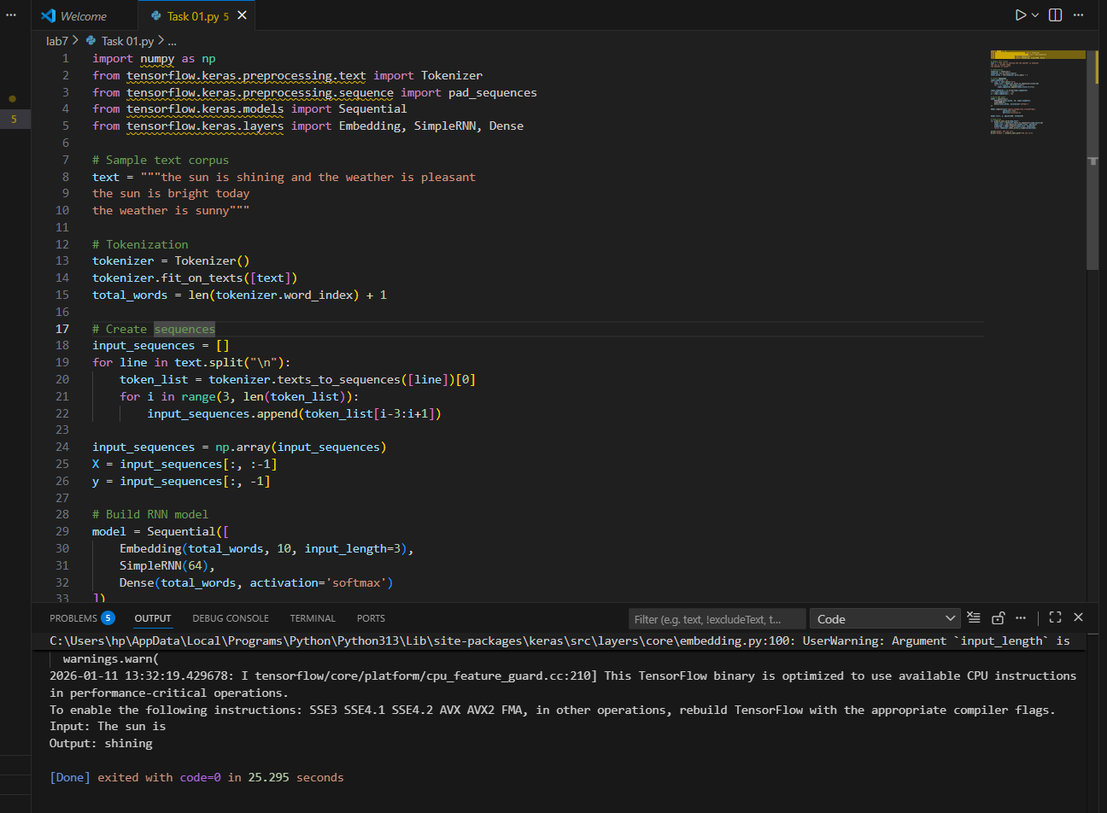
----------------------------------------------------------------------------------------------------

LAB Task 2:
Stock Price Prediction using RNN
Objective: Predict future stock prices using time series data.
Dataset: Use Google Stock Price dataset (from Kaggle or Yahoo Finance).
Tasks:
- Import dataset and normalize values.
- Prepare time-step sequences (e.g., 60 previous days → next day price).
- Build and train an RNN model using SimpleRNN layers.
- Evaluate predictions vs actual prices (plot graph).
Output:
Line graph showing predicted vs real stock price trend.
Required Solution
- Understanding of dataset
- Understanding of code
- Learning outcomes analysis
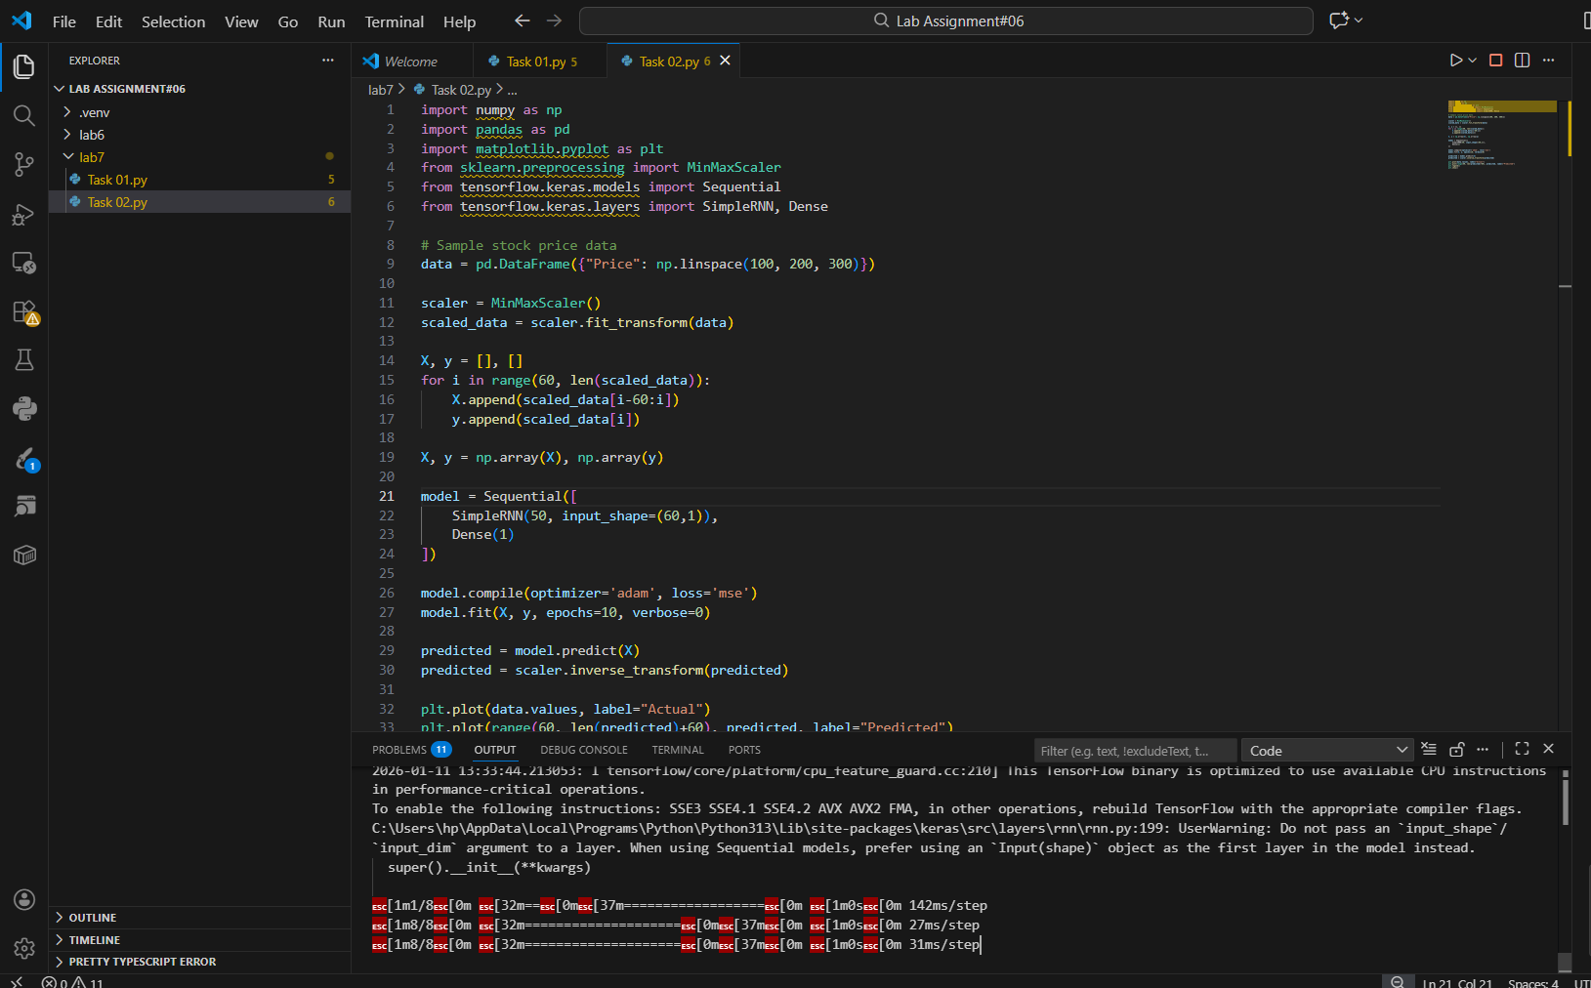
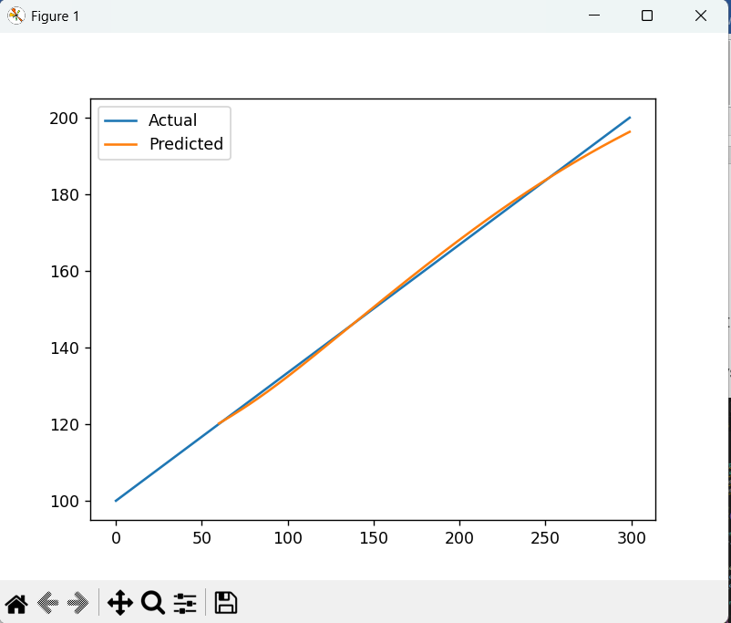
-------------------------------------------------------------------------------------------------------
LAB Task 3:
Sentiment Analysis using RNN
Objective: Classify movie reviews as positive or negative using RNN.
Dataset: IMDb Movie Reviews dataset (available in Keras).
Tasks:
- Load dataset and preprocess text (tokenize and pad sequences).
- Build RNN with Embedding + SimpleRNN layers.
- Train for binary classification (positive/negative).
- Evaluate accuracy on test data.
Output:
Accuracy score (e.g., 85%) and prediction for custom input text.
Required Solution
- Understanding of dataset
- Understanding of code
- Learning outcomes analysis
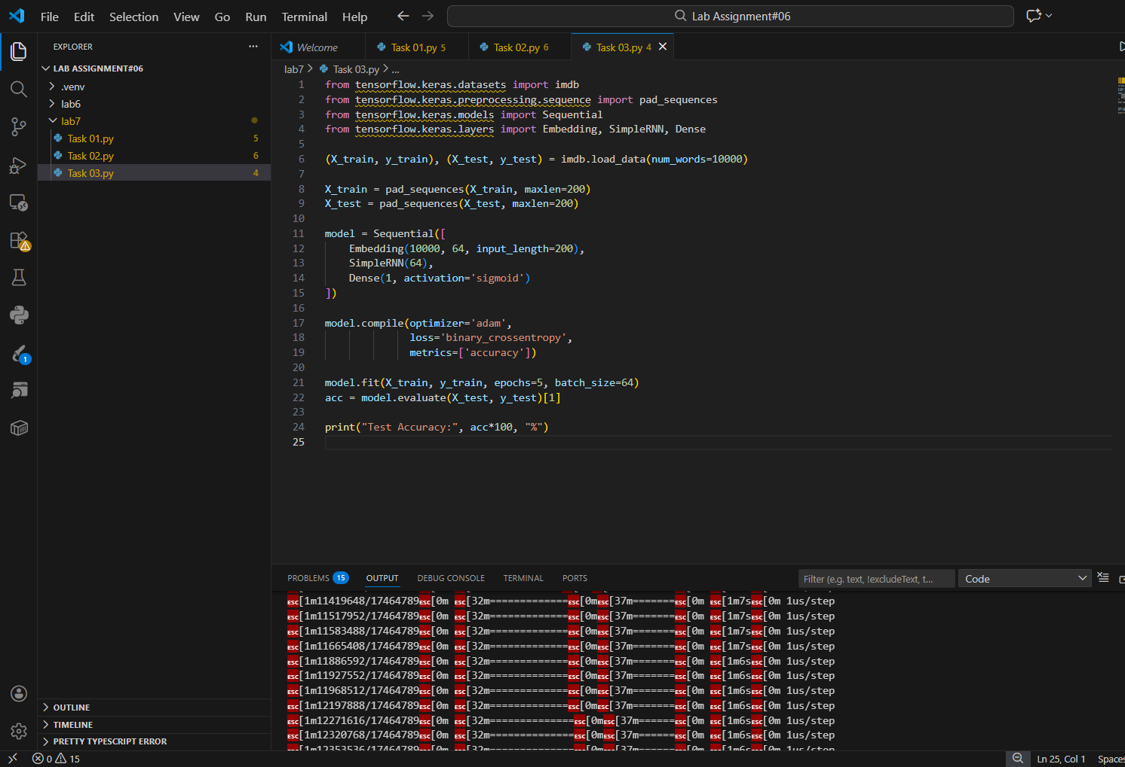
----------------------------------------------------------------------------------------------------

LAB Task 4:
Weather Forecasting using RNN
Objective: Predict future temperature based on previous days’ readings.
Dataset: Daily temperature dataset (e.g., “Jena Climate Dataset” from TensorFlow).
Tasks:
- Load and visualize temperature over time.
- Prepare input-output sequences for time series prediction.
- Build an RNN to predict next day’s temperature.
- Plot actual vs predicted temperature.
Output:
Graph showing predicted vs actual temperature trends.
Required Solution
- Understanding of dataset
- Understanding of code
- Learning outcomes analysis
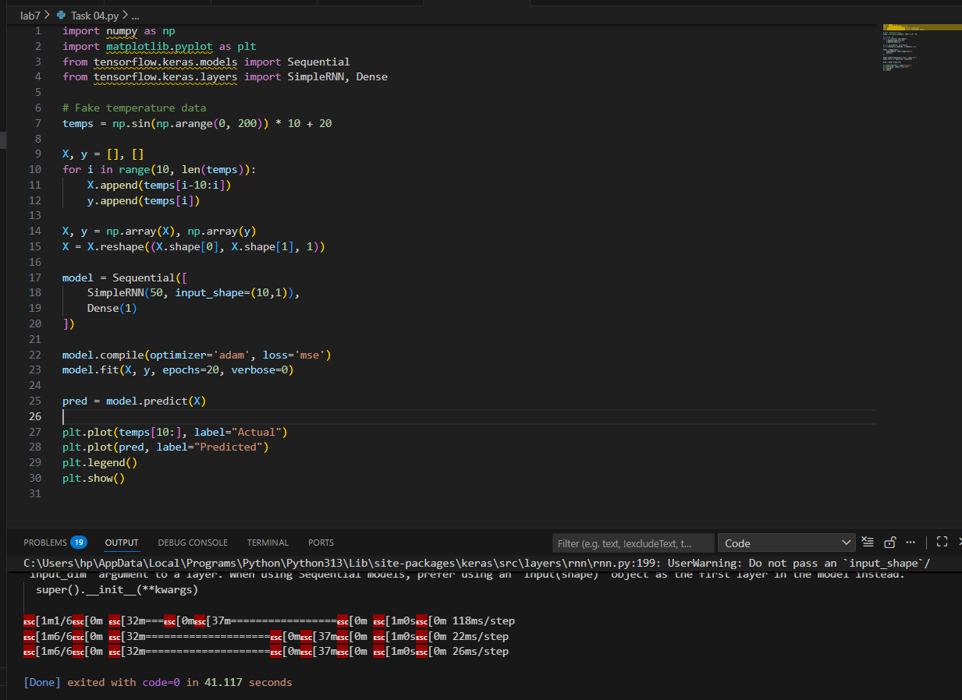
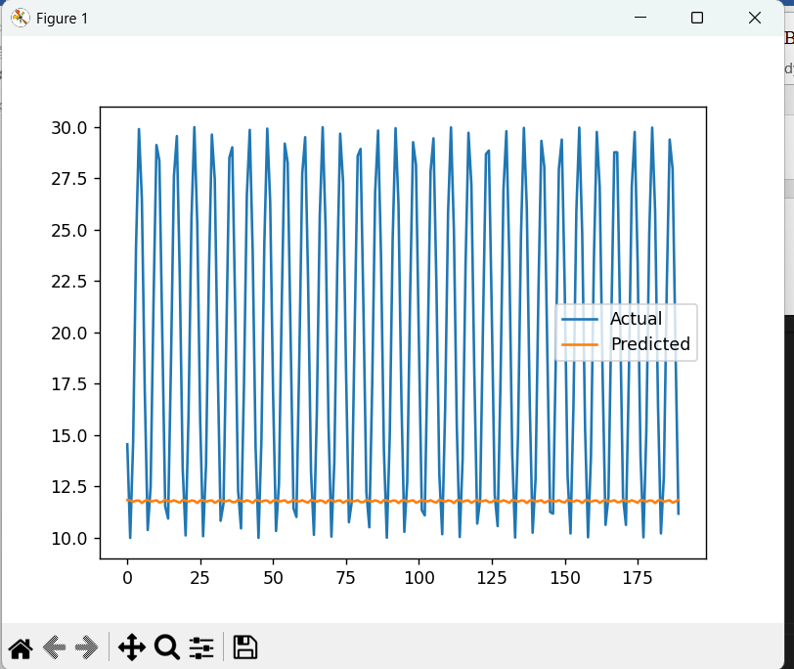
------------------------------------------------------------------------------------------------------

LAB Task 5:
Music Note Generation using RNN
Objective: Generate new music sequences using RNN.
Dataset: MIDI music dataset (short sequences or melodies).
Tasks:
- Convert MIDI data into integer-encoded notes.
- Train an RNN on note sequences (input: previous notes → output: next note).
- Generate a new sequence using the trained model.
Output:
A sequence of generated notes that can be converted to a playable MIDI file
Required Solution
- Understanding of dataset
- Understanding of code
- Learning outcomes analysis

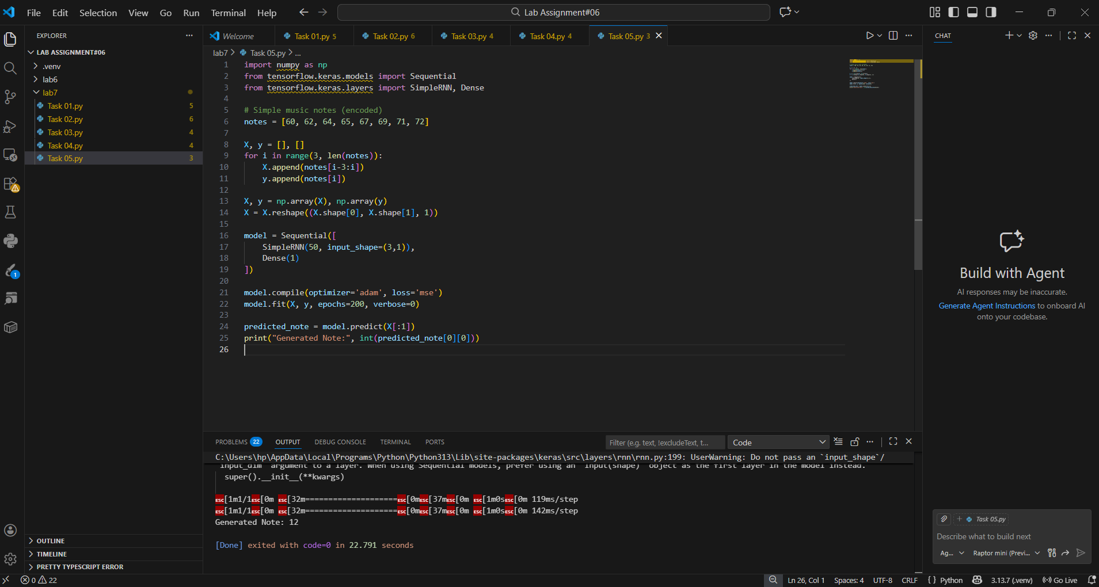

LAB Assessment

Student Name |  | LAB Rubrics | CLO3 , P5, PLO5
Student Name |  | Total Marks | 10
Registration No |  | Obtained Marks
Registration No |  | Teacher Name | Dr. Syed M Hamedoon
Date |  | Signature

